Selenium Testing Setup

|  |  |  |  |
| --- | --- | --- | --- |
| **Version** | **Date** | **Affected Section** | **Author** |
| 1.0 | 04/04/2019 | Initial Draft | Matthew Mc Colgan |

Contents

Introduction 2

Prerequisites 2

Steps 2

References 5

# Introduction

Selenium WebDriver is an opensource web automation framework to execute tests against different browsers. You can write your tests in multiple languages including C#, Java, PHP etc. It can operate across multiple OS’s and can be integrated with many frameworks including NUnit and other applications like Jenkins.

# Prerequisites

Visual Studio Community Edition

Sample MVC app created by Charles. Can be downloaded/cloned from GitHub @ <https://github.com/rlennon/CrowSoft/tree/CSoftDevBranch/Projects/crowsoftmvc>

# Steps

1. Open the sample MVC app in VS Community
2. Right click on the Solution



1. Select “Add” and choose “New Project”.
2. Select “Test” -> “NUnit Test Project (.NET Core)” and give it a name. Click “OK” when done.

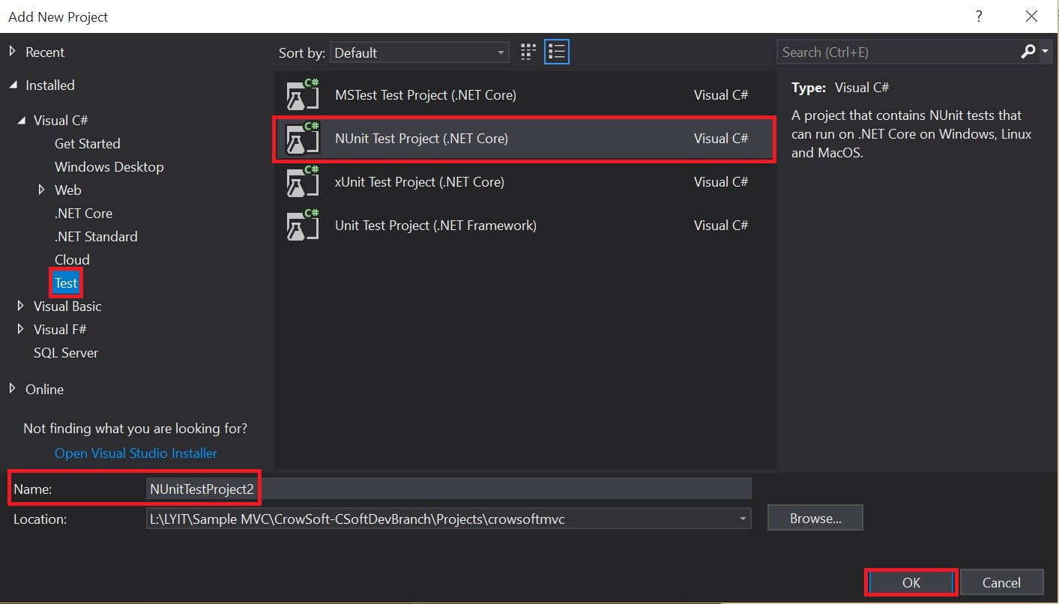

1. Right click on the newly created project and select “Manage NuGet Packages”

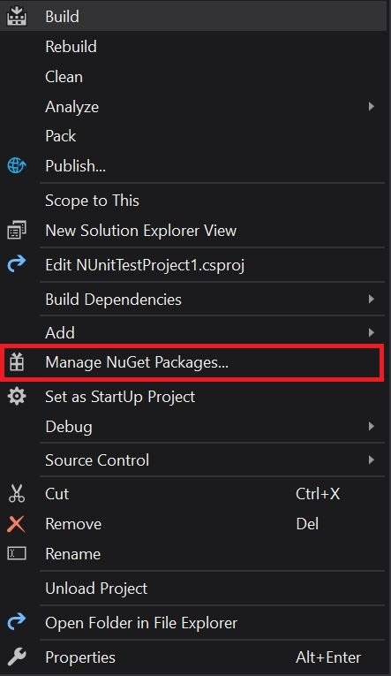

1. You can browse for the required NuGet packages using the Browse tab. Select the required package and click install on the pane in the right.

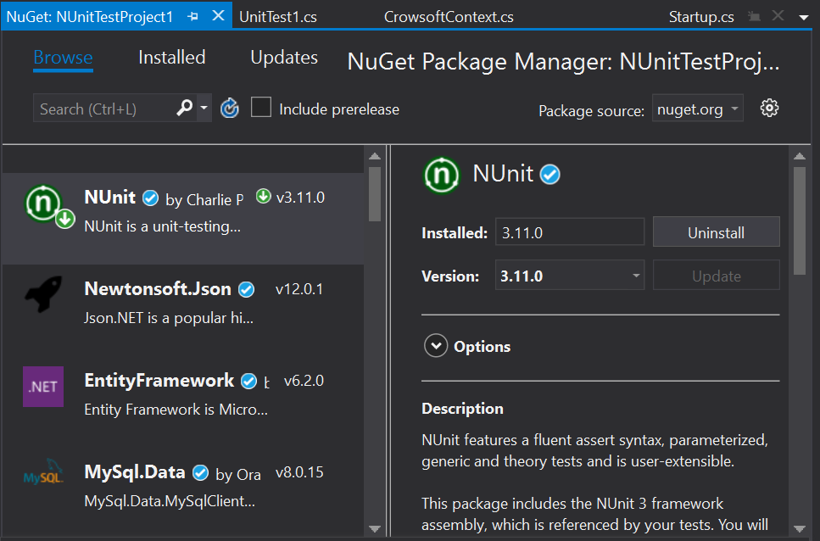

1. Install all of the following NuGet packages:
   1. Microsoft.NET.Test.SDK
   2. Microsoft.NETCore.TestHost
   3. Selenium.Chrome.WebDriver
   4. Selenium.WebDriver
2. Download chromedriver.exe from the following link <http://chromedriver.chromium.org/downloads>. Make sure to download the driver that corresponds to the version of chrome you are using.
3. Place the chromedriver.exe in your project folder (see code below)**
4. Open the UnitTest1.cs file that was automatically generated when creating the project and paste the following code:

using NUnit.Framework;

using OpenQA.Selenium;

using OpenQA.Selenium.Chrome;

namespace Tests

{

public class Tests

{

public class SeleniumTests

{

IWebDriver driver;

[SetUp]

public void startBrowser()

{

driver = new ChromeDriver("L:/LYIT/Sample MVC/CrowSoft-CSoftDevBranch/Projects/NUnitTestProject1/bin/Debug/netcoreapp2.2");

} **Change path to suit where your chromedriver is installed**

[Test]

public void test()

{

driver.Url = "https://localhost:44380";

}

[TearDown]

public void closeBrowser()

{

driver.Close();

}

}

}

}

1. Open the Test Explorer and run the test.

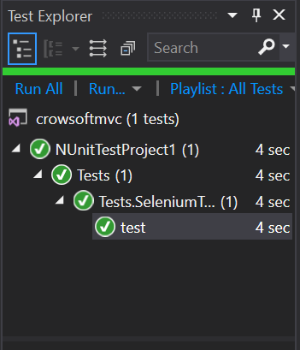

# References

<http://chromedriver.chromium.org/downloads>

<https://www.lambdatest.com/blog/13-reasons-why-selenium-webdriver-should-be-your-first-choice-for-automation-testing/>

<https://www.guru99.com/selenium-csharp-tutorial.html>